A. Installation for Windows computer and Android phone (Part 1 of 2)

1. Download Visual Studio Community by entering this URL <https://visualstudio.microsoft.com/vs/> in your browser, hovering over “Download Visual Studio”, then clicking “Community” Graphical user interface, text, application, chat or text message

   Description automatically generated
2. Click the downloaded installer

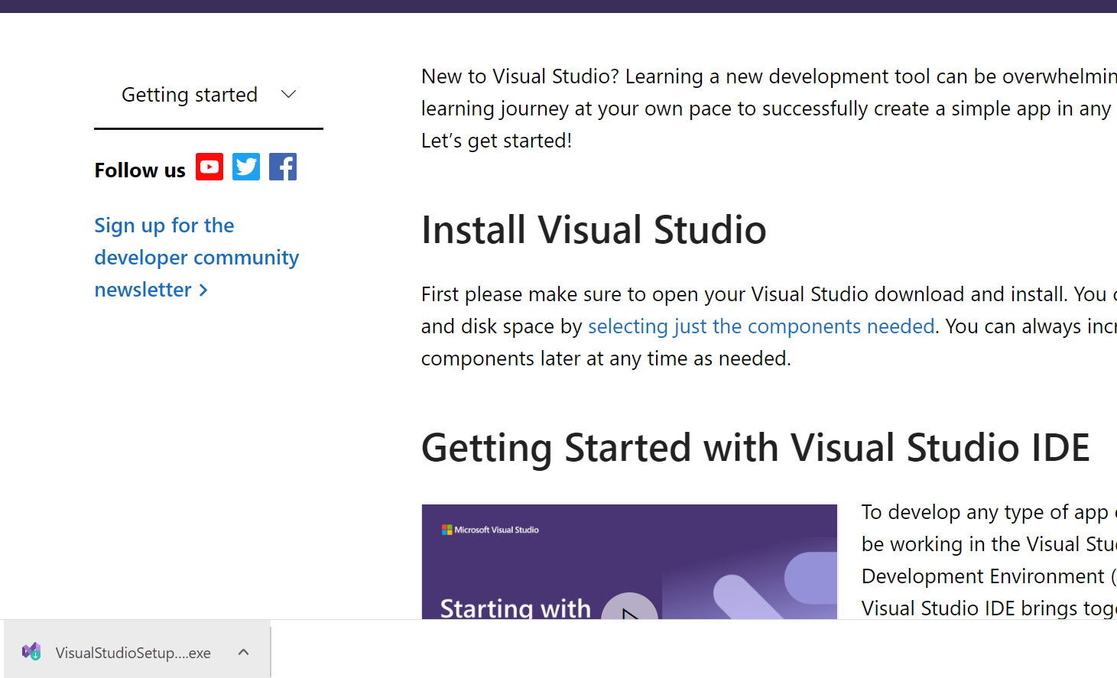

1. Allow administrator rights by clicking “Yes” or entering administrator username and password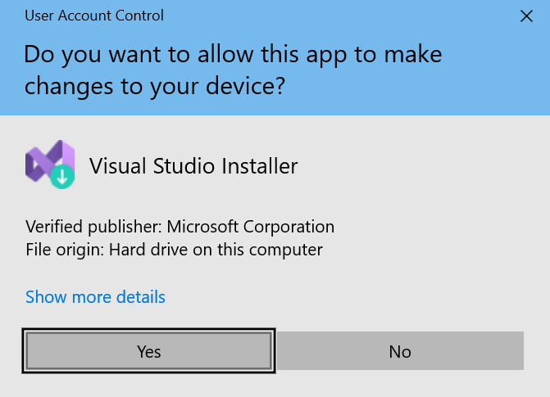
2. Click “Continue” 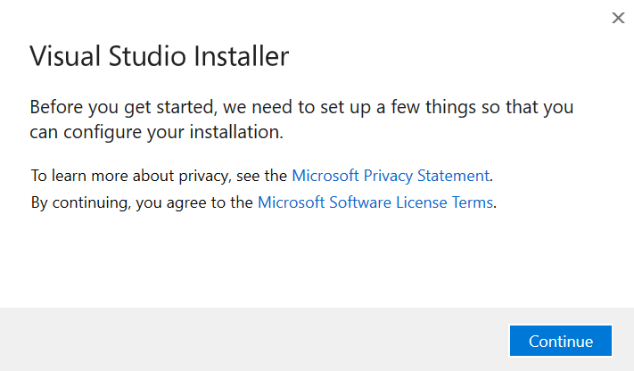
3. Click “Mobile development with .NET” then “Install” Graphical user interface, application

   Description automatically generated
4. While waiting for installation, continue onto step 7 at the same timeGraphical user interface, application

   Description automatically generatedGraphical user interface, application, Teams

   Description automatically generated
5. Enable USB Debugging in your Android phone   
   (NOTE: the Settings UI is different for each brand, below UI is for stock Android)
   1. Go to “Settings” > (if Android 8.0 or 8.1: “System” > ) “About phone” > Hit “Build number” for 7 times until get a message “You are now a developer!”
   2. Back to “Settings”, open “Developer options” and enable “USB debugging” switch > Tap OK.  
      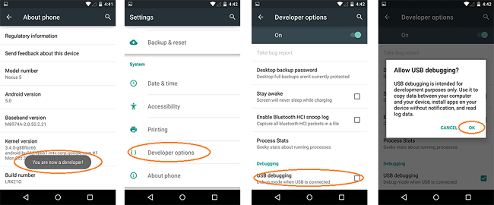
   3. Plug your phone into the computer via a USB cable 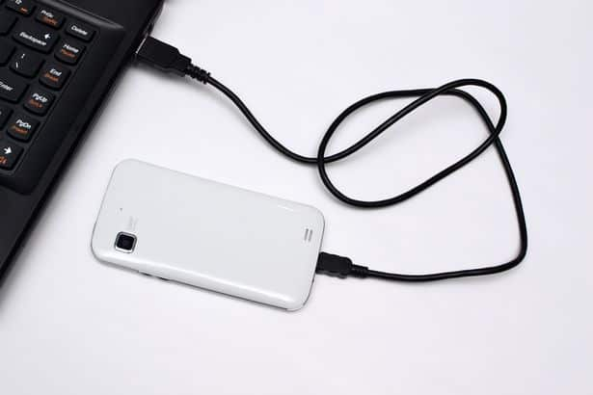
   4. Verify that the “Use USB for” selection appears or use another USB cable capable of data transfer instead of just charging the phone. Press “File transfer/Android Auto”Graphical user interface

      Description automatically generated with medium confidence
6. After Visual Studio installation completes, click “Not now, maybe later” Graphical user interface, application, Word

   Description automatically generated
7. Click “Start Visual Studio” Graphical user interface

   Description automatically generated
8. Wait a bit more Graphical user interface, application

   Description automatically generated

B. Getting the template

1. Click “Clone a repository” Text

   Description automatically generated
2. Paste https://github.com/Happypig375/PedoApp2 into Repository location, then click Clone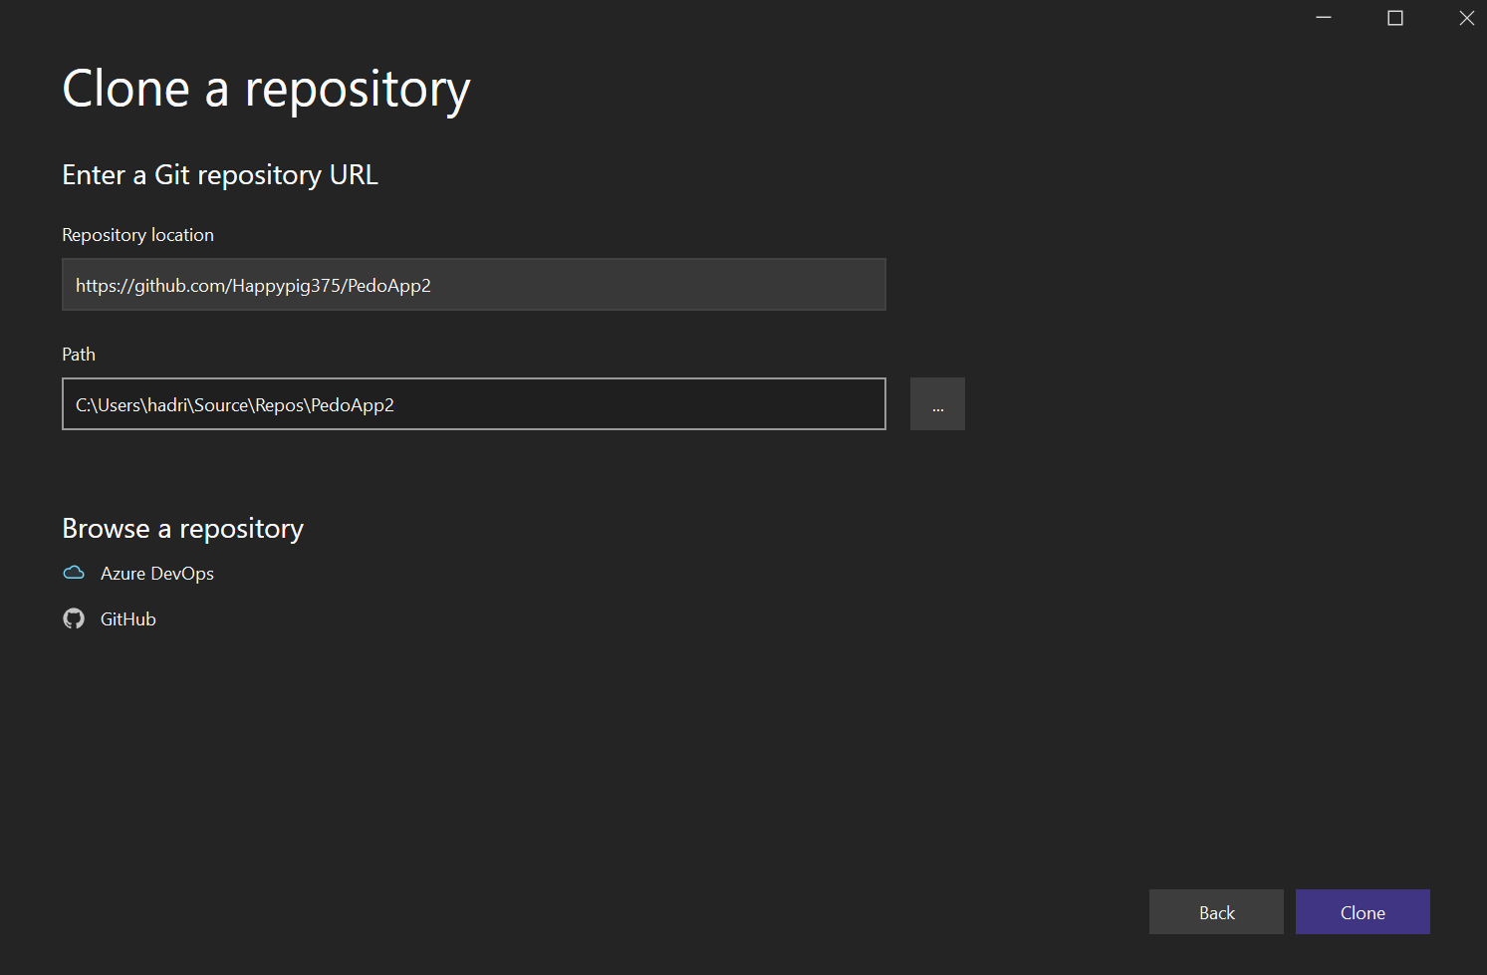
3. Wait for download 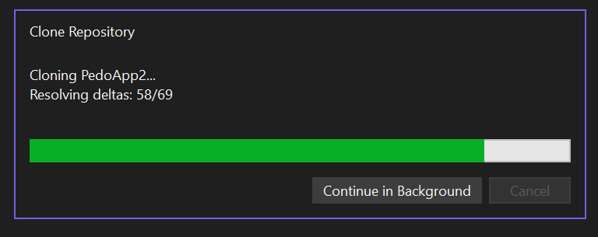

C. Installation for Windows computer and Android phone (Part 2 of 2)

1. Click “Accept” for “Android Sdk License” A screenshot of a computer

   Description automatically generated with medium confidence
2. Allow administrator rights by clicking “Yes” or entering administrator username and password 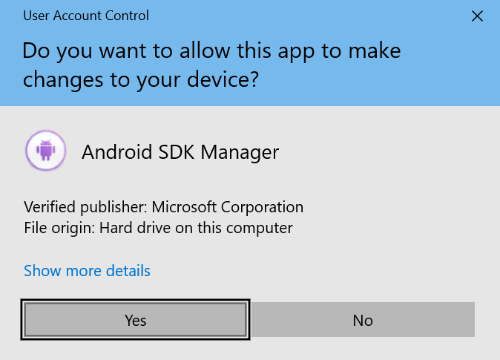

D. App overview

1. Click the dropdown arrow next to “App” and click “App.Android”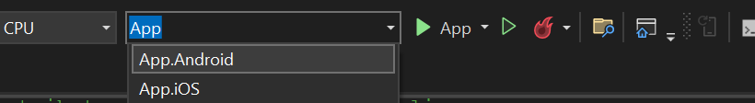
2. Click the dropdown arrow to the right of the green right-pointing triangle and click the option with your phone model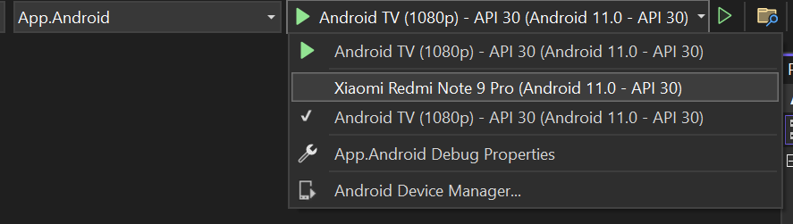
3. Press the green right-pointing triangle and wait for the app to build. Meanwhile, look at your phone for the next step  
   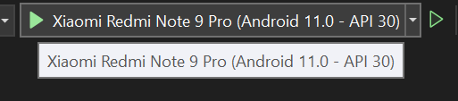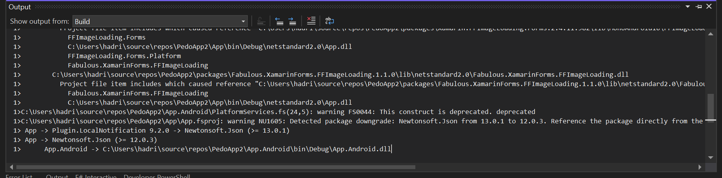
4. Press “Install” once the installation prompt comes up. You only have 10 seconds to accept, or accept the computer screen error prompt and repeat from the previous step  
   A screenshot of a phone

   Description automatically generated with medium confidence
5. Press “Allow” Graphical user interface, application

   Description automatically generated
6. Test the pedometer by walkingGraphical user interface, application, chat or text message

   Description automatically generated
7. Press the menu buttonGraphical user interface, application, chat or text message

   Description automatically generated
8. Press “Alarm” Graphical user interface, application, Teams

   Description automatically generated
9. Icon

   Description automatically generatedIcon

   Description automatically generatedWe have some bugs here! Graphical user interface, application

   Description automatically generated

E. Bugfixing

1. Click to open Solution ExplorerA screenshot of a computer

   Description automatically generated with medium confidence
2. Click to open “App” dropdown Graphical user interface, application

   Description automatically generated
3. Double click to open App.fs A screenshot of a computer

   Description automatically generated with medium confidence
4. Hover over “Edit” at the top, then hover over “Find and Replace”, then click “Quick Find” 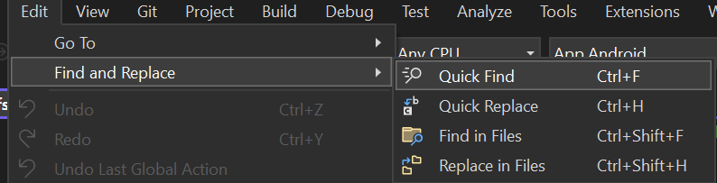
5. Type “todo” in the find prompt at the top right corner 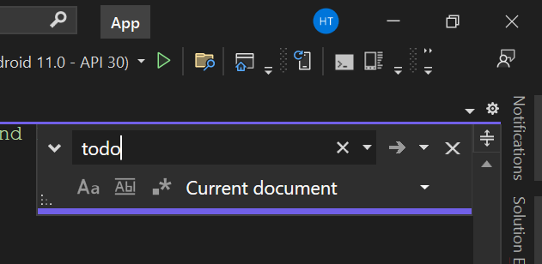
6. See the “TODO”s highlighted. The vertical scroll bar also highlights for lines containing these TODOs.

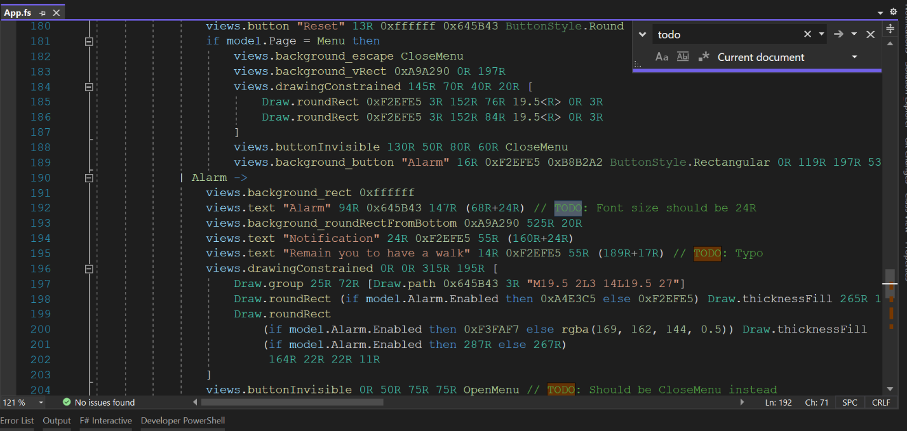

1. For example, on line 205, we have a TODO: Set the height to 50R.  
   First try to understand what that line is doing by hovering over the yellow part buttonInvisible  
   
2. Explanation: this is an invisible button, with its left edge at 250 (“R”atio-defined units), top edge at 150 (“R”atio-defined units), width of 75 (“R”atio-defined units), and height of 0 (“R”atio-defined units), and pressing it will cause a SwitchAlarm. It’s obvious that a button of zero height will not be desirable and the TODO tells us to change the height to 50 (“R”atio-defined units) instead.